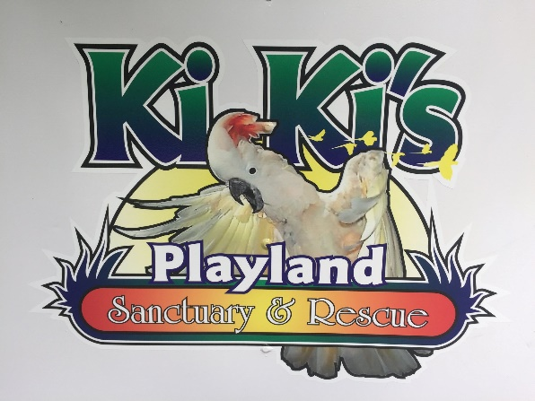

KiKi’s Playland Parrot Sanctuary and Rescue
Surrender form
Kiki’s Playland Parrot Sanctuary and Rescue is a 501(c)(3) non-profit organized to assist parrot owners by educating them about the proper care of these exotic birds. However, we at Kiki’s realize that there are times when a new home may be in the best interest of all involved.
At this time, you are asking Playland Parrot Sanctuary and Rescue to take possession of the parrot listed below. Understand that you are giving up all rights of ownership to this bird and are asking that a new owner be found. In order to find the best home possible, please answer the following questions truthfully.

Bird’s name: Click or tap here to enter text. Breed: Click or tap here to enter text.

Age:Click or tap here to enter text. Sex: M ☐/ F ☐/ Unknown ☐ Are the wings clipped? Yes ☐ / No ☐

How long have you owned this bird? Click or tap here to enter text.

What type of diet has this bird been fed? Click or tap here to enter text.

Name of veterinarian that you have taken this bird to: Click or tap here to enter text.

Have any health tests been done on this parrot? Yes ☐ / No ☐
If so, what tests?
Click or tap here to enter text.
Please list any known health issues:
Click or tap here to enter text.

Please list any bad habits this bird has: (cage aggression, biting, profanity…..)
Click or tap here to enter text.
How does this bird react to the following? Please highlight all that apply
Children: Good / Scared of them / Indifferent to them / Aggressive towards them / Unknown
Men: Good / Scared of them / Indifferent to them / Aggressive towards them / Unknown
Women: Good / Scared of them / Indifferent to them / Aggressive towards them / Unknown
Dogs: Good / Scared of them / Indifferent to them / Aggressive towards them / Unknown
Cats: Good / Scared of them / Indifferent to them / Aggressive towards them / Unknown
Other birds: Good / Scared of them / Indifferent to them / Aggressive towards them / Unknown
Is this bird able to be handled without gloves or towel? Yes ☐ / No ☐
How much time does this bird spend in the cage? Click or tap here to enter text.
How much time does this bird spend out of the cage? Click or tap here to enter text.
How often does this bird interact with people out of the cage? Click or tap here to enter text.

Does this bird talk? Yes ☐ / No ☐
If so, what words does he/she say?
Click or tap here to enter text.
Is there anything else we should know about this bird?
Click or tap here to enter text.

Your signature below indicates that you are agreeing to surrender ownership of this bird and that you have answered all questions truthfully and to the best of your knowledge.

Signature: Click or tap here to enter text. Date: Click or tap to enter a date.

